
Housing with Care
A summary report on our findings
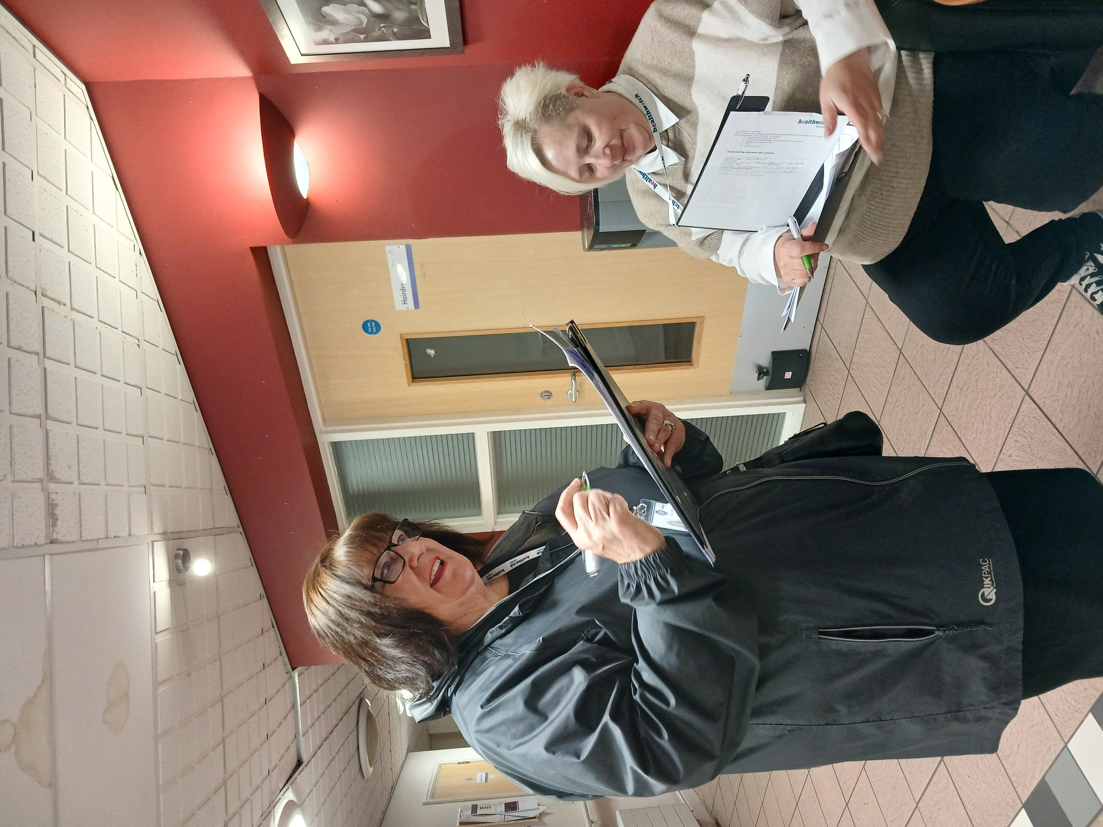
Humber Court

????@

Contents

Contents 1
Introduction 2
Methodology (how we did this research) 3
What Residents told us 4
Communication 5
What Staff told us 6
What we Observed 7
Conclusion 8
Recommendations 9
Our thanks 13

Disclaimer:
This report is based solely on the views, experiences and feedback shared directly by people during our Enter & View Visit. Healthwatch Coventry acts as an independent voice for service users, reporting their words and perspectives verbatim without alteration, interpretation or addition of our own opinions. Our role is to amplify people’s voices to support service improvements, and the findings reflect only what was contributed on the day of the visit, not a comprehensive assessment of all experiences.
Acknowledgement
Terminology within this report reflects, what people say and how people describe their experience, both the language used by individuals and the correct service model.
People living in these schemes hold tenancy agreements and are therefore tenants. The term ‘resident’ is used to reflect everyday language people used, how people refer to themselves as and does not imply a residential care setting.
References to catering and activities also reflect language used during visits. Catering provisions available, although terminology (e.g. ‘restaurant’ or ‘café’) may vary. The provision of activities may also be from perspective of people, as these are not always commissioned, though some schemes provide them as an additional feature.
Our approach ensures the report reflects people’s voices while remaining factually accurate.

Introduction
Our role as Healthwatch Coventry is to hear the voices of those people who are using health and social care services, so that we can share their voices with services to help them to understand the issues and improve.

Our Housing with Care project developed the work that we had started in Autumn 2024 to look deeper into how people were experiencing their health and care services living in Housing with Care schemes.

We wanted to explore the services on offer to help schemes to understand the issues and improve.

The report looks at the environment, building, activities, communication, personalisation of services and care. Food and wellbeing of the people living in the schemes. We look at recommendations and highlighted areas for best practice. This report focuses on Humber Court which is managed by Extra Care and is a snapshot of what people felt and thought, as well as what we observed at the time.

At Humber Court we spoke with 12 people about how they experienced the scheme, what care they received, and what they thought of that care, how they organised their food, what activities if any they participated in, and whether they found the building met their needs. From their replies we used themes to understand their experiences were and make recommendations for change.

From their replies we used themes to understand their views and share positive feedback and recommendations for consideration of changes which could make a positive difference.

“It’s very good new staff haven't as much experience and don't understand needs as much”



Methodology
We created a survey for residents’ staff and family members to ask them about their experiences of their housing with care scheme
We visited each housing with care scheme and spoke to them about our visit and set a date to attend

We made observations at each scheme. Looking at the environment and interactions with members of staff and resident

We briefed our Authorised Representatives about the project.

We raised awareness of our project through social media.
We have written a report outlining our findings and recommendations to go to housing with care schemes, Adult Social Care, and Care Quality Commission for response.

When the responses are given, we will publish our report

At Humber Court we spoke to 12 people about their experiences in this Housing with Care scheme.
We looked at:
- How personalised their experience was.
- How good the care and support and does it meet their needs
- What activities are available and what do they participate in, and what are their thoughts
- We asked whether residents received enough communication
- What the food was like in the café and did it meet their needs
- Whether the building and environment was livable and suitable

What residents told us

What we learned and what residents told us about their experiences in Housing with Care at Humber Court.
What we learnt Residents Comments
x

Personalisation

5 Residents rated excellent
6 Residents rated good
1 Residents rated alright

Friends and family play an important part in the care checking on residents and helping them with tasks.

Activities
10 residents take part in activities
1 resident said that activities are good or excellent
Residents would like more activities
They are in between volunteer coordinators
“The staff are nice if you fall can call down to them using pull cord.”

“Lived locally before coming here holds lots of memories”

“Manager is very good; they employ staff that are not only caring but also interesting. They have caring instincts.”

“Do get asked if there were any activities I would like to do used to have a monthly bulletin to say what activities are coming up, it used to be delivered to my flat. It is on the main notice board I go to knitting and chair tai chi”

“Armchair yoga. Wouldn’t miss it for the world! Have a process whereby the residents call reception every morning to say they are ok.
Sometimes people have their radios on too loud

“I would like to be organised with GPs exercise on prescription Leisure Centre used to do it I could do more things myself in mind and body”

Communication
Communication

Need to look at language barriers and types of food provided for residents from different culture

11 residents say they have enough information for their needs

Food and nutrition

The food seemed to meet residents needs 8 residents rated their food over 8/10
But cost is an issue

Building and Environment

I
9 residents though the building was excellent or good and there were no issues with repairs
x

“Mental health worker is very good and supportive. Vaccinations are sorted so don't have to go out. 15 minutes given for personal care to include wash and getting dressed not enough time for this. Cleaning - not well organized”

“Buy food from the cafe and bring back to room and cook own veg to go with it”

“It’s very nice and everyone is very friendly and the food is good I have put weight on (a good thing) no noises If I wasn’t happy my daughter will sort it out If I need anything she brings it”

“The scheme is between activity coordinators”

“Worried about finance and costs going up. Would like to have a cash machine within the home”

“It’s big enough for us. Within flat: Issues around the height of the kitchen cupboards - too high and not allowed to stand on anything to reach. Also the depth of the bottom cupboards is too big so struggle to get stuff if pushed too far back. All the sockets in the kitchen are close together - better having them spaced out. No space for a freezer”

`

What staff told us

Positive
The job can be deeply rewarding. Having a good balance between professional challenging
I like helping and working with residents most.
Working at Humber court has provided the opportunity for professional growth and the ability to maintain personal connection to people.

Good working hours excellent kitchen. Very supported
Nice environment, nice staff approachable manager

Working at Humber court has provided the opportunity for professional growth and the ability to maintain personal connection to people.

What could be improved
I think it’s harder because people are living longer and NHS is in such a bad way - it is having an impact. waiting lists are a concern
Because communication comes from head office down, could be better/clearer
Nice environment, nice staff approachable manager

At times additional resources -fast-paced environment ever changing
Streamlining administrative tasks
More dedicated time for staff development.
More dedicated time for staff development.

What we observed
Food has to be ordered a day in advance |  | No smells inside, looked clean from inside door
Food smelt nice |  | Residents sitting in reception waiting for lifts to go out
Watched a staff member going round asking people what they wanted for pudding |  | Welcoming displays of pumpkins and autumn crafts.
Warm, welcoming people are in the communal areas |  | Minimal noise, low level of music playing
Carers speaking effectively, clearly, manner raising voice slightly if required, respectfully listening |  | 5 residents as reminiscence session, staff led the session but didn’t take over. Knew people’s names, and included everyone in discussions
Garden area, grassed area lots of seating, |  | Entry is bright and welcoming
Good signs on doors |  | Residents were very happy with their activities

“I would like to be organised with GP’s exercise on prescription, leisure
centre used to do it- did it in another place. I could do more things for myself in mind and body”


“Excellent- it’s nice and warm, everyone is friendly, if I need to go shopping, my relatives take me once a fortnight”

“Worried about finances and costs going up. Would like to have a

cash machine within home relatives don’t live close so have to get a taxi across to Asda to use cash point there”

Conclusion
Housing with Care schemes are valuable in terms of the support they provide to people who can no longer live independently at home due to their mental and physical needs and do a great job in sometimes difficult circumstances – lack of staff, changing needs of residents and other things.
We were impressed with Humber Court and the welcoming nature of the scheme, its residents who felt very supported and independent and treated the communal areas as their own
Activities were excellent – we observed chair yoga and reminiscence group attended by residents, but others with different hobbies would value more
We were interested in the concerns about what is to come in terms of housing with care, and those who will need support in the future but also value their independence to live a full worthwhile life
This provides a strong foundation to build on through continued partnership working

Please see below our recommendations that we are asking you to respond to, to say what you are doing or what you are planning to do (you may already be taking lots of actions to meet these recommendations. Please complete our recommendations using the table and return it to us – see next steps.
Recommendations

What could help improve the services
Issue | Recommendation | Response
More activities for Men | Ask residents for their ideas, have an ideas meeting/box | This has already been discussed with residents at the most recent street meeting. Letters were distributed to residents in January inviting suggestions for activities; however, the response was limited. As a result, this was further discussed during the street meeting to encourage engagement and gather ideas directly from residents. A resident activity suggestion box has now been introduced within the scheme to allow residents to provide ideas at any time. In addition, the Activity Coordinator has arranged a focused resident meeting on 26 March 2026 to specifically gather ideas for future activities, including activities that may appeal more to male residents. The Activity Coordinator will review suggestions regularly and work with residents to develop activities based on the feedback received.
Training for staff as they would like more | Look at staff meeting to discuss or through supervision | Training needs are reviewed regularly through supervision and team meetings. Additional opportunities for staff development will continue to be identified through the supervision process and through the organisation’s training platform.
Extra resources for staff | Plan in any addition resource for peak times to support staff | Staffing levels are regularly reviewed to ensure residents’ needs are met. Humber Court will continue to monitor peak periods and review rota planning to ensure adequate staffing support is available during busy times.

General Recommendations
Recommendation | Response | Date
Making sure car park areas are clean of rubbish plastic gloves), disabled bay marked clearly | External areas, including the car park, are maintained by our contracted grounds maintenance provider Lakeside, who carry out regular monthly maintenance visits. The disabled parking bay has been reviewed and is clearly marked. The location team will continue to monitor the area and report any concerns to the contractor to ensure the environment remains clean and safe for residents and visitors. | On Going
Ensure hot and cold taps are marked accordingly | Hot and cold tap identification will be clearly displayed within communal bathrooms. The maintenance team will install appropriate hot/cold stickers on taps to ensure they are easily identifiable and to support resident safety. | April 2026
Have an easy-to-follow leaflet (or other communication) for new residents explaining insurance, resident's meetings | Humber Court will review the current welcome information provided to new residents and ensure key information such as insurance, resident meetings and scheme information is clearly explained in a simple and accessible format. | On Going
Look at good quality and more diverse cultural dishes on the menu | The Chef Manager holds quarterly resident catering meetings where residents can provide feedback on the menu and suggest new dishes. During these meetings residents are encouraged to share ideas for culturally diverse meals and preferences. The catering team will continue to review menu options and consider introducing a wider variety of culturally diverse dishes where possible based on resident feedback. | On Going
Look at colourful posters and fliers in large print and that people in wheelchairs can access | Communication materials will be reviewed to ensure posters are clear, large print and accessible for residents including those using wheelchairs. | On Going
Look at resources and funding for activities | Humber Court will explore opportunities for additional resources including volunteers, partnerships with community organisations and potential funding streams to enhance the activity programme. | On Going
Ask residents what they would like to see as activities – have a suggestion box | Resident meetings and suggestion boxes are used to gather ideas and feedback to ensure the activity programme reflects resident interests and preferences. In addition, focused resident meetings are held quarterly to discuss activities and encourage residents to share ideas and suggestions for future events and groups. | On Going
Ensure that all staff know what activities are happening in the scheme and can talk about them to residents | Activity schedules will continue to be shared with staff during daily line-ups and displayed in communal areas to ensure all staff are aware and able to promote activities to residents. | On Going
Impact:
Healthwatch Coventry will continue to work with partners to review progress and support improvements.
Accountability - recommendations section:
We expect responses to outline actions, timelines and how improvements will be monitored.

What Happens next,
This report and recommendations will have been sent to Housing with Care group managers for a response to our recommendations, these have been added to this report. We will then review the actions after three and six months to see if these actions have been followed.

If you would like more information or have questions about this report, please contact yoursay@healthwatchcoventry.co.uk

Our Thanks
To all the residents and staff at Humber Court, Housing with Care units for allowing us to speak with them and for sharing with us a glimpse of their lives and experiences.
Thanks to the managers who helped and supported us to set dated and help us on the day.
A big thank you to the Healthwatch Coventry Authorised Representatives who are crucial to make the work happen.


Humber Court



Healthwatch Coventry
The Wheelhouse
Coventry City Council House
Earl Street
Coventry, CV1 5RR
www.healthwatchcoventry.co.uk
Telephone: 0300 012 0315
E-mail: yoursay@healthwatchcoventry.co.uk

Hosted By:
Citizens Advice Mid Mercia 114 Church St, Church Gresley, Swadlincote, Derbyshire, DE11 9NR

