

Housing with Care
A summary report on our findings
Henry Court, Leofric Lodge Wyken Court
Autumn/Winter 2025
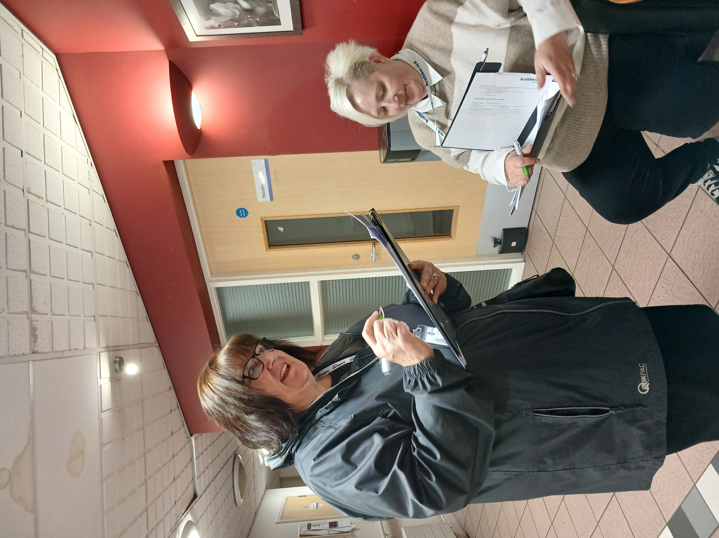


Contents
Contents………………………………………………………………………………………………………………1
Introduction 2
Methodology 3
What Residents Told Us……………………………………………………………………………..4
Communication……………………………………………………………………………………………..5
What staff told us 6
What we observed 8
Conclusion 9
Recommendations………………………………………………………………………………………10
Our Thanks……………………………………………………………………………………………………………………13

Disclaimer:
This report is based solely on the views, experiences and feedback shared directly by people during our Enter & View Visit. Healthwatch Coventry acts as an independent voice for service users, reporting their words and perspectives verbatim without alteration, interpretation or addition of our own opinions. Our role is to amplify people’s voices to support service improvements, and the findings reflect only what was contributed on the day of the visit, not a comprehensive assessment of all experiences.
Acknowledgement
Terminology within this report reflects, what people say and how people describe their experience, both the language used by individuals and the correct service model.
People living in these schemes hold tenancy agreements and are therefore tenants. The term ‘resident’ is used to reflect everyday language people used, how people refer to themselves as and does not imply a residential care setting.
References to catering and activities also reflect language used during visits. Catering provisions available, although terminology (e.g. ‘kitchen’, ‘restaurant’ or ‘café’) may vary. The provision of activities may also be from perspective of people, as these are not always commissioned, though some schemes provide them as an additional feature.
Our approach ensures the report reflects people’s voices while remaining factually accurate

Introduction
Our role as Healthwatch Coventry is to hear the voices of those people who are using health and social care services, so that we can share their voices with services to help them to understand the issues and improve.
Our housing with care project developed the work that we had started in Autumn 2024 to look deeper into how people were experiencing their health and care services living in housing with care schemes.

We wanted to explore the services on offer to help schemes to understand the issues and improve.

The report looks at the environment, building, activities, communication, personalisation of services and care. Food and wellbeing of the people living in the schemes. We look at recommendations and highlighted areas for best practice. This report focuses on Henry Court, Wyken Court and Leofric Lodge who are managed by Anchor Housing. This report is a snapshot of what people felt and thought, as well as what we observed at the time.

At Henry Court we spoke to 18 people, at Leofric Lodge we spoke to 9 people and at Wyken Lodge we spoke to 9 people about how they experienced the scheme, what care they received, and what they thought of that care. We looked at how they organised their food, what activities if any, they participated in, and whether they found the building met their needs.

From their replies we used themes to understand their experiences were and make recommendations for change.


“Not happy not happy that I don't see the same people and that they write in my book”

“I am always singing the care is brilliant staff always keep me informed lighting temperature and noise levels good. They respect my privacy & dignity. I don’t need personal care”

Methodology
We created a survey for residents, staff, and family members to ask them about their experiences of their Housing with Care scheme
we visited each Housing with Care scheme and spoke to them about our visit, and set a date to attend

We created a survey for residents, staff, and family members to ask them about their experiences of their Housing with Care scheme
We made observations at each scheme. Looking at the environment and interactions with members of staff and resident

We briefed our Authorised Representatives about the project.

We raised awareness of our project through social media.

We have written a report outlining our findings and recommendations to go to Housing with Care schemes, Adult Social Care, and Care Quality Commission for response.

When the responses are given, we will publish our report

At Henry Court we spoke to 18 residents, At Wyken Court, we spoke to 9 residents, at Leofric Lodge we spoke to 9 residents about their experiences in these Housing with Care schemes.
We looked at:
- How personalised their experience was, and how it met their needs.
- How good the care and support were and does it meet their needs
- What activities are available, what do residents participate in, and what are their thoughts.
- We asked whether residents received enough communication
- What the food was like in the café and did it meet their needs
- Whether the building and environment was livable and suitable.

What residents told us

What we learned and what residents told us about their experiences in Housing with Care at Henry Court, Leofric Lodge and Wyken Court.

What we learned Residents comments
Personalisation

Care and support
Residents appreciated their independence and “freedom”
Carers don’t always ask what people would like to happen

Activities
Staff go the extra mile, especially when there is no activities coordinator

80% of residents said they participate in activities

80% said the activities were good or excellent

“Staff are always very pleasant and friendly they know who we are. They put an easier quiz which was better for me and the others”

“I will feel safer on the first floor. Other people using walkers in their room and corridor it is noisy”

“I like the flat the carers are nice there could be more common sense they shower and dress me without drying my hair”

“I am not happy I don’t see the same people and that they write in my book”

“Excellent because this is my room, and I can do what I want. I feel like I am at home.”

“I do bingo and other things. I like something to do; you get bored if you don’t.”

“The staff stay behind after their shift and help with parties.”

Communication
Communication

80% of residents said that they get enough information

Staff are good at telling people what is happening
Food and nutrition

There was a mixture of responses to the food, some residents liked their family to bring food

“Café is expensive"

Building and Environment

There are issues with long term repairs and scaffolding that impact on residents
“Notice boards and posters are too high for someone in a wheelchair have notices that you can take with you -idea go to other schemes.
I don’t get enough information; some share it with me or not.”
x

“I sometimes eat in the cafe; the food is lovely”

“My relative get bits and bobs pieces in. The cafe is too dear for what they do too much roast chicken. I like Caribbean.”

“My carers do it sometimes staff don’t wash their hands one sneezed on food”

“All right [building] It’s not very old can’t see any damage up to now no damage.”

“I don’t like the area we are in – want to go”

“Lifts keep breaking down - need to have both lifts working. Need new carpets in the hallway.”

“Crap - aerials no good reception bad can’t get a picture.”

“Had a leak on the first day and oven broke, Reported to manager downstairs. Once electric tripped because of too many appliances.”

What staff told us

Positive
Single parent annual leave flexibility variety of days. the residents are great
I like this place because it seems organised and the management listens to everyone’s voice. There is teamwork. I really feel at home together with lovely residents.

The team is the best I’ve worked for and always help me in finding a solution. The carers support me.

You meet and interact with the residents. Staff are good and it’s a friendly atmosphere.

I enjoy my role, customers and all the staff I work with

Working conditions, all staff and customers, very professional and friendly, great support from manager
Nice work environment. Staff all lovely. Customers are lovely too.

What could be improved
It is challenging finding the time to build rapport with residents due to the short number of hours my role has. To consistently build rapport 30 to 35 hours would be good.
Communication about residents, handovers and so on are good, it’s more the staffing

More communication is needed. Staff/management communication is lacking about shifts, rotas etc. Rota should be 4 weeks but hasn’t been.

Some residents are challenging.
I feel very well supported; I have no anxieties around my role. I like the different characters; we have been to the Stoke Community Centre and hope to go there again.
Can be quite busy. We are understaffed. Lack of communication between all staff

Pricing in the cafe is very high, older residents can't afford it. The backlash is towards staff, and we have no control over prices.

What we observed
A resident became rather poorly, male staff came out, briefly asked what was wrong, and said he would ring 999, resident became upset, said "No don’t call the police she was upset. I explained it would be an ambulance not police. Staff went away to office, I asked the resident if she needed the toilet, staff came back and I said she needs the toilet. |  | Lounge, café very busy in the morning and at lunch time
Staff chatting, asking residents how they are |  | Pleasant calm atmosphere
Lots of residents and family chatting downstairs, felt buzzing, pleasant |  | Library. Mini pool table, large connect 4 in café/games area
Staff reacting and joking with residents, not patronising controlled noise, fun. |  | Café bit untidy
Very welcoming member of staff met us outside |  | Sight switch outside toilets unclears, bit untidy tissues in the basin
Café area busy with people preparing food, one staff member cut up an apple for a resident |  | Lots of information boards around reception
Gentle conversation, quiet voices, staff and residents |  | Spoke to one resident who had been for a walk. They were happy
Watched carers taking resident away to give them their medication |  | Carer translating for Punjabi speaking to resident
Some light switches hard to find, had emergency lighting – bit confusing |  | We spoke to people who have just moved to the scheme and were experiencing a change

“It’s been a shock to my system because I’m used to being independent but the staff have helped me”

Conclusion
Housing with Care schemes are valuable in terms of the support they provide to people who can no longer live independently at home due to their mental and physical needs, and staff do a great job in sometimes difficult circumstances – lack of staff, changing needs of residents and other things.
The standard of care was evident when we spoke to residents although some residents were concerned with the local area they were in however two residents said that carers don’t give the best standard of clealinness
The activities were well regarded, but people didn’t feel they had to participate and were happy with the freedom and independence they had.
The ongoing work to buildings and small complaints about health and safety, need addressing for residents to feel safe. could be communicated better to residents and implemented more around what was happening and when.
Staff find that they are short of time to develop their relationships with clients as much as they would like.
There is a lack of culturally different food, and some residents find it too expensive to eat in the café.
Staff are not always supported by management when facing challenging behaviors from residents.
This provides a strong foundation to build on through continued partnership working

Please see below our recommendations that we are asking you to respond to, to say what you are doing or what you are planning to do (you may already be taking lots of actions to meet these recommendations) Please complete our recommendations using the table and return it to us – see next steps.

Recommendations
What could help improve the services?
Issue | Recommendation | Response
Resident and visitors’ difficulties finding light switches, and not sure of taps. (All 3 sites) | Make sure light switches and other items are identified and can be seen | Fixtures and fittings are managed by Anchor Housing and not the care service. Recommendation Sent to housing manager to comment
Lack of culturally different foods (All 3 sites) | Explore different cultures with resident input | We will take this comment on board and look to seek resident input
Food too expensive (All 3 sites) | Look at cost points | Cost points are explored and local café price points taken into consideration, we are currently breaking down the menu for customers to show there are cheaper alternatives on the base menu.
Building and repairs make life more difficult for residents (Henry Court & Leofric Lodge) | Look at action plan and communication to residents | Fixtures and fittings are managed by Anchor Housing and not the care service. Recommendation Sent to housing manager to comment
Challenging behaviour of residents (All 3 Sites) | Training on handling conflict or Mental health First Aid | We have taken this to Anchor who have provided some training, we currently use Coventry City College for colleagues to gain a recognised qualification in both subjects
Look at more and relatable activities (All 3 Sites) | New activity coordinator in soon for one. Ask residents for suggestions e.g. suggestion box | Suggestion boxes in place and a lot of work currently being done in this area, we take your comment on board and will look to expand this area

General recommendations
Recommendation | Response | Date
Making sure car park areas are clean of rubbish plastic gloves), disabled bay marked clearly (all 3 sites) | Car park Area is managed by housing manager, recommendation passed to housing to comment | None given
Ensure hot and cold taps are marked accordingly (all 3 sites) | Taps and other fixtures are managed by housing manager, recommendation passed to housing to comment | None given
Have an easy-to-follow leaflet (or other communication) for new residents explaining insurance, resident's meetings (all 3 sites) | This area is for the housing manager; recommendation passed to housing to comment | None given
Look at good quality and more diverse cultural dishes on the menu (all 3 sites) | We will take this comment on board and look to seek resident input | On Going
Look at colourful posters and fliers in large print and that people in wheelchairs can access (all 3 sites) | We will take this comment on board | On Going
Look at resources and funding for activities (all 3 sites) | New activity coordinator in soon for one. | On Going
Ask residents what they would like to see as activities – have a suggestion box (all 3 sites) | Suggestion boxes in place and a lot of work currently being done in this area, we take your comment on board and will look to expand this area | On Going
Ensure that all staff know what activities are happening in the scheme and can talk about them to residents. (all 3 Sites) | Not Answered | None given

Impact:
Healthwatch Coventry will continue to work with partners to review progress and support improvements.
Accountability - recommendations section:
We expect responses to outline actions, timelines and how improvements will be monitored.

What happens next?
This report and recommendations will have been sent to Housing with care group managers for a response to our recommendations, these have been added to this report. We will then review the actions after three and six months to see if these actions have been followed.

If you would like more information or have questions about this report, please contact yoursay@healthwatchcoventry.co.uk

Our Thanks
To all the residents and staff at Henry Court, Wyken Court and Leofric Lodge Housing with Care units for allowing us to speak with them and for sharing with us a glimpse of their lives and experiences.
Thanks to the managers who helped and supported us to set dated and help us on the day.
A big thank you to the Healthwatch Coventry Authorised Representatives who are crucial to make the work happen.

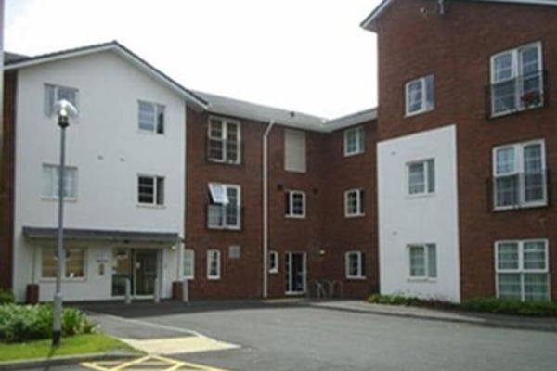

Henry Court
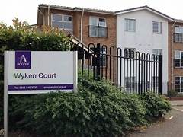

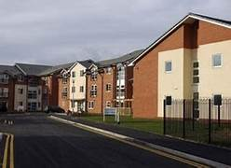

Wyken Court

Leofric Lodge



Healthwatch Coventry
The Wheelhouse
Coventry City Council House
Earl Street
Coventry, CV1 5RR
www.healthwatchcoventry.co.uk
Telephone: 0300 012 0315
Email: yoursay@healthwatchcoventry.co.uk

Hosted by:
Citizens Advice Mid Mercia 114 Church St, Church Gresley, Swadlincote, Derbyshire, DE11 9NR

