

Housing with Care
A summary report on our findings
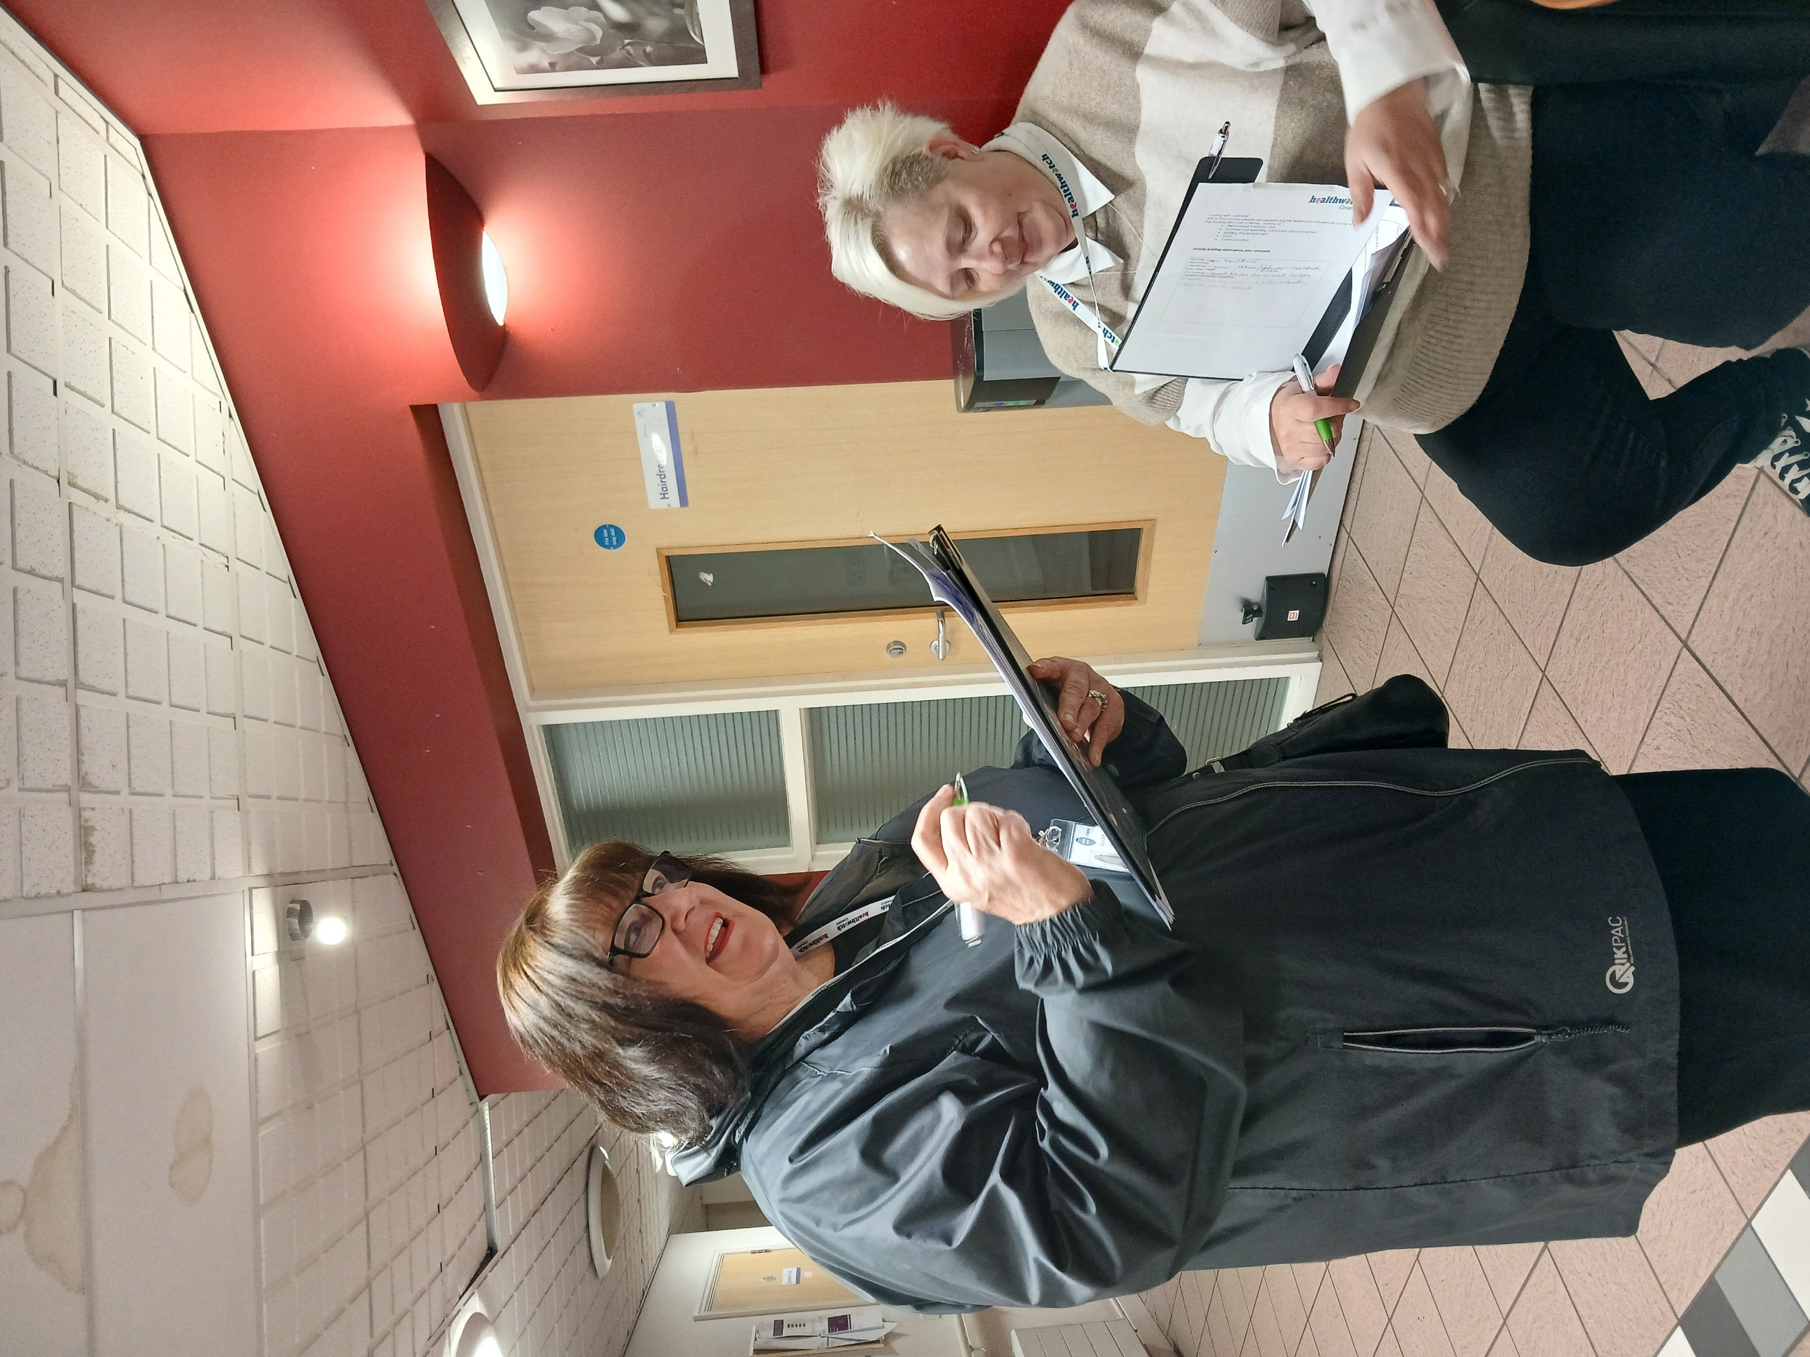
Copthorne Lodge, Knightlow Lodge and Quinton Lodge

Contents

Contents
Contents………………………………………………………………………………………………2
Introduction……………………………………………………………………………………….2
Methodology…………………………………………………………………………………….3
What Tenants told us………………………………………………………………….4

Communication ……………………………………………………………………………5
What staff told us:…………………………………………………………………………6
What we observed………………………………………………………………………..7

Conclusion…………………………………………………………………………………………8
Recommendations……………………………………………………………………….9
Our Thanks………………………………………………………………………………………………….12
Disclaimer:
This report is based solely on the views, experiences and feedback shared directly by people during our Enter & View Visit. Healthwatch Coventry acts as an independent voice for service users, reporting their words and perspectives verbatim without alteration, interpretation or addition of our own opinions. Our role is to amplify people’s voices to support service improvements, and the findings reflect only what was contributed on the day of the visit, not a comprehensive assessment of all experiences.
Acknowledgement
Terminology within this report reflects, what people say and how people describe their experience, both the language used by individuals and the correct service model.
People living in these schemes hold tenancy agreements and are therefore tenants. The term ‘resident’ is used to reflect everyday language people used, how people refer to themselves as and does not imply a residential care setting.
References to catering and activities also reflect language used during visits. Catering provisions available, although terminology (e.g. ‘restaurant’ or ‘café’ for residents only) may vary. The provision of activities may also be from perspective of people, as these are not always commissioned, though some schemes provide them as an additional feature.
Our approach ensures the report reflects people’s voices while remaining factually accurate.

Introduction
Our role as Healthwatch Coventry is to hear the voices of those people who are using health and social care services, so that we can share their voices with services to help them to understand the issues and improve.

Our Housing with Care project developed the work that we had started in Autumn 2024 to review and now look deeper into how people were experiencing their health and care services living in Housing with Care schemes.

We wanted to explore the services and offer to help to hear the voices of those people living within the scheme.

The report looks at the environment, building, activities, communication, personalisation of services and care. Food and wellbeing of the people living in the schemes. We look at recommendations and highlighted areas for best practice. This report focuses on Copthorne Lodge, Knightlow Lodge, and Quinton Lodge which are managed by Citizen and Coventry City Council for Care. This is a snapshot of what people felt, everyday language and thoughts, as well as what we observed at the time.

At Copthorne Lodge we spoke to 12 tenants, at Quinton Lodge we spoke to 7 tenants and at Knightlow Lodge we spoke to 9 tenants about how they experienced the scheme, what care they received, and what they thought of that care. We looked at how they organised their food, what activities if any, they participated in, and whether they found the building met their needs.

From their replies we used themes to understand their views and share positive feedback and recommendations for consideration of changes which could make a positive difference.

“I still get to keep my independence. Staff have got to know me, and it is wonderful being listened to”

Methodology
we visited each Housing with Care scheme and spoke to them about our visit, and set a date to attend
We created a survey for tenants, staff, and family members to ask them about their experiences of their Housing with Care scheme

We made observations at each scheme. Looking at the environment and interactions with members of staff and tenants

We briefed our Authorised Representatives about the project

We raised awareness of our project through social media.
We have written a report outlining our findings and recommendations to go to Housing with Care schemes, Adult Social Care, and Care Quality Commission for response.

When the responses are given, we will publish our report

At Copthorne Lodge we spoke to 12 tenants, Quinton Lodge we spoke to 7 tenants and at Knightlow Lodge we spoke to 9 tenants about their experiences in these Housing with Care schemes.
We looked at:
- How personalised their experience was, and how it met their needs.
- How good the care and support were and does it meet their needs
- What activities are available, what do tenants participate in, and what are their thoughts.
- We asked whether tenants received enough communication
- What the food was like in the café and did it meet their needs
- Whether the building and environment was livable and suitable.

What tenants told us

What we learned and what people told us about their experiences in Housing with Care at Copthorne Lodge, Quinton Lodge and Knightlow Lodge.

What we learned Tenants comments
Personalisation
20 Tenants said that living in these Housing with Care schemes was excellent or good

Care and support
People valued their care, but said “sometimes staff are busy” we asked people how they rated their care and support

There was a range of rating scores, but 22 tenants scored 8 or above for care and support

Activities
14 tenants participated in activities
We asked what the activities are like
11 tenants rated good
8 tenants rated all right
3 tenants rated very poor
6 tenants didn’t comment

“The support I get meets my needs its good, it does help me in my everyday life”

x

“You get used to it living here. Carers are very nice here we have a laugh they do a good job”.

“Support is sometimes good and sometimes bad. If I needed it I could ask for it they say” I am busy sometimes”

“There is no place like home but living here is a bit like living at home”

"I want Zumba, but the lady cannot do it because not all the tenants can take part”

“Used to [have activities] but not enough staff to do it now
Dec carol singers coming in”

Communication

Food
Although hard to meet everyone’s needs for food 14 tenants rated between 8 and 10

Communication

20 tenants said they receive enough information for their needs,

There was a feeling that sometimes you have to ask for information

People who could not see posters found it difficult to know what was going on
People with literacy issues or less English also struggled

Building and Environment
20 tenants said the building was excellent or good
People were happy with repairs
The fridge in the lounge was noisy


“Meals not too bad”

“Price of meals is ok. We have a monthly menu. We have roast dinners and fish and chips”

“I find that with the cost of rent and care it’s not affordable to then use the cafe too.”

“We could do with help with our benefits and what we are entitled to”

“If you want to know something you have to ask”

“Not sure, sometimes I think I miss things because I can’t see very well”.

“It is in pretty good shape. If I tell them there is something wrong, they come straight away”

“Good it’s my home, we don't get any issues problems I feel safe here they've done the bathroom done kitchen last year everything is new”

“The fridge is a pain sometimes I can’t hear people speak (Fridge)”

What staff told us:
We are like a family we work as a team

It’s rewarding to know that I am making a difference to people’s lives – making them feel happy and safe

Positive
I feel supported if I need help I speak to the management and staff
Housing with Care is a very productive environment staff get chances to develop and help if they need it.
The tenants will say how they enjoyed their meal and what they don’t like so I can work with them
I love my job

What could be improved
More outside activities – lost to others because too much work
Managers sometimes change things and don’t listen to staff

More time to communicate with tenants – give them time to talk
Being Listened to and communicating with staff and tenants

More staff to listen to each other care for each other work together
The way referrals work for units are handled could be made better by streamlining
Karaoke for tenants

What we observed
We observed a residents meeting and saw a positive action as a resident was helped to organise an activity afternoon, this was immediately publicised around the scheme |  | Residents sitting together chatting, calm and peaceful
The buildings were warm, comfortable and homely with smells of cooking – but very pleasant |  | Café wasn’t open so one resident having food taken upstairs to her flat
Groups of residents having their lunches, interacting with staff with music playing |  | Old rubber gloves scattered in carpark KL car park looked uncared for
Some stains on corridor carpet QL |  | Staff laying tables for lunch – there are tablecloths – feels good to be there.
Residents waiting to go out and about in the community. (Community access is tenant-led and undertaken independently) |  | Small signage by front door, could be bigger
Warm and welcoming entrance busy feel |  | Fridge in living/dining area very loud so it’s hard to hear people speak, including talking with residents


“They could do more activities; nothing ever really happens about that. I’d like a pool table. They are trying to set up a social club”
“Very Happy here. Moved in last year after my relative died I have learning difficulties. I have someone to help with housework plus friend comes and does my shopping. The staff will help if needed. Overall staff are excellent & helpful”

Conclusion
Over all the tenants felt that their care was good, and their needs were met, it felt personalised to the individual and there we observed positive relationships between tenants and staff
Some tenants went out into the local community for meals – they enjoyed this.
There were concerns for some tenants that the food was too expensive on top of their rent
Tenants felt that the scheme was good overall and that it was like living in a home from home,
There was a feeling that staff are stretched and busy, so sometimes are not as available as tenants like
We got the sense that people were feeling isolated and wanted more activities, especially activities they were interested in.
People who have English as a Second Language or have literacy needs can struggle to understand what is going on.
Staff felt that more could be done to support each other and make time to listen to each other, especially management
This provides a strong foundation to build on through continued partnership working

Recommendations (see also main report and general recommendations below)

Please see below our recommendations that we are asking you to respond to, to say what you are doing or what you are planning to do (you may already be doing lots of actions to meet these recommendations). Please complete our recommendations using the table and return it to us – see next steps.

Recommendations

What could help improve the services
Issue | Recommendation | Response
Residents feel they do not always know what is on (All 3 sites) | Make all communications accessible (large print wheelchair height boards, consistent staff briefings accessible | Introducing large-print, accessible noticeboards and clearer weekly “What’s On” updates.
Not enough activities – some residents feel they are isolated. (All 3 Sites) | Have it on the agenda at residents meeting – have an ideas box, get residents to find out more about how they could deliver activities | Activities are not commissioned as part of the 7-hour care package. Staff support and facilitate activities where capacity allows, and we are strengthening tenant-led and community-based opportunities to increase sustainability.
Support for benefits checks (All 3 Sites) | Plan to provide access to information e.g. Coventry CA, Coventry Independent Advice service | Housing with Care staff do not provide direct benefits advice. Tenants and families are supported to access appropriate external agencies such as Coventry Citizens Advice, Coventry City Council’s Financial Assessment Service, or accredited welfare-rights providers. Staff can signpost, assist with contact and support with correspondence.
Communication and information (All 3 Sites) | Look at tenants/resident’s meetings and see how they could report back to the rest of the tenants in a different way –  One resident asked for a newsletter. | Piloting a monthly tenant newsletter to enhance information flow.  Increasing verbal communication for residents with literacy or visual needs.  Ensuring information displayed in corridors is purposeful and accessible, in line with CQC expectations around visible information to support engagement.
Ongoing costs of services (All 3 Sites) | Support with finance and benefits | Staff can signpost, assist with contact and support with correspondence.
Building – easy to find/ park (All 3 Sites) | Address environmental quick wins, repaint disabled bays, clear car park rubbish (if any) improve signage | Temporary signage for corridors at Quinton Lodge is now in place, and permanent signage has been requested.  Flooring: New flooring is currently being installed across all communal areas at Copthorne Lodge.

General Recommendations
Recommendation | Response | Date
Making sure car park areas are clean of rubbish plastic gloves), disabled bay marked clearly (All 3 Sites) | PPE found externally is typically linked to visiting external care agencies, and KL staff are not expected to handle or dispose of external PPE waste for infection-control reasons  We are contacting all external agencies working within our schemes to reinforce expectations regarding PPE disposal  A request to review and repaint disabled bays has been escalated to Citizen Estates for assessment/action | On Going
Ensure hot and cold taps are marked accordingly – signage for identification | Escalated to Citizen Estates for assessment/action. | 24th March 2026
Have an easy-to-follow leaflet (or other communication) for new tenants explaining insurance, residents/tenants’ meetings (All 3 Sites) | Piloting a monthly tenant newsletter to enhance information flow. Increasing verbal communication for tenants with literacy or visual needs. Newsletter pilot underway; verbal updates increased; household insurance discussed in tenant guide and added to next tenant meeting agenda | On Going
Look at good quality and more diverse cultural dishes on the menu (All 3 Sites) | Feedback on café affordability and choice is noted; however, the catering function is funded separately to the care service. Tenants who do not wish to use the café have full kitchens in their flats and are able to prepare their own meals independently, ensuring they retain choice and control over their nutritional needs. Café now a standing item at tenant meetings; kitchen staff to attend future meetings for direct menu input. | On Going
Look at colourful posters and fliers in large print and that people in wheelchairs can access (All 3 Sites) | Large-print boards, weekly “What’s On,” verbal updates, purposeful corridor displays | On going
Look at resources and funding for activities (All 3 Sites) | Activities not commissioned within the 7-hour package; tenant-led and community-based options encouraged. | N/A
Ask residents what they would like to see as activities – have a suggestion box (All 3 Sites) | Tenant-led activity groups strengthening; activities now a standing agenda item; external partners explored; new tenant co-chair appointed at Copthorne. | On going
Ensure that all staff know what activities are happening in the scheme and can talk about them to tenants (All 3 Sites) | Activity coordination added as standing agenda item; weekly activity briefings planned in handovers | On going

Impact:

Healthwatch Coventry will continue to work with partners to review progress and support improvements.

Accountability: Recommendations section:

We expect responses to outline actions, timelines and how improvements will be monitored.

What Happens next
This report and recommendations are sent to Housing with Care group managers for a response to our recommendations, these have been added to this report. We will then review the actions after three and six months to see if these actions have been followed.

Our Thanks
To all the residents and staff at Copthorne Lodge Housing with Care unit, Knightlow Lodge Housing with Care unit, Quinton Lodge Housing with Care unit for allowing us to speak with them and for sharing with us a glimpse of their lives and experiences.
Thanks to the managers who helped and supported us to set dates, and visit the units
A big thank you to the Healthwatch Coventry Authorised Representatives who are crucial to make this work happen.
If you would like more information or have questions about this report, please contact yoursay@healthwatchcoventry.co.uk

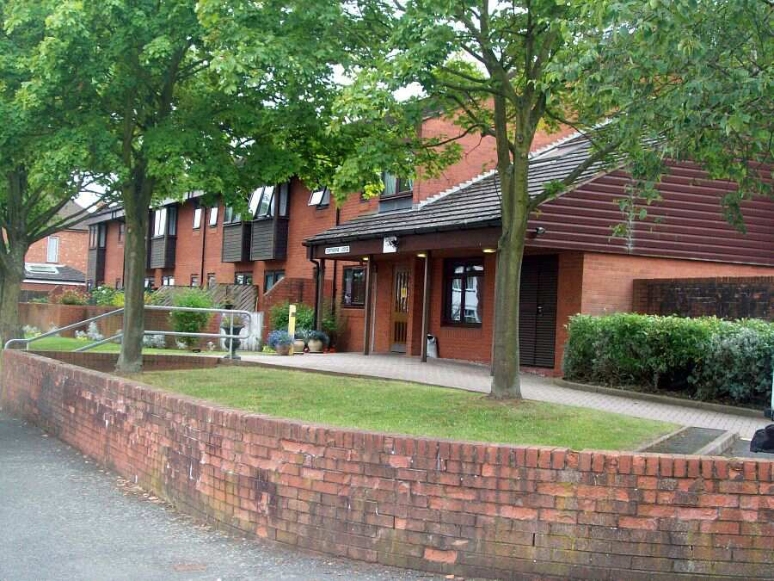

Copthorne Lodge

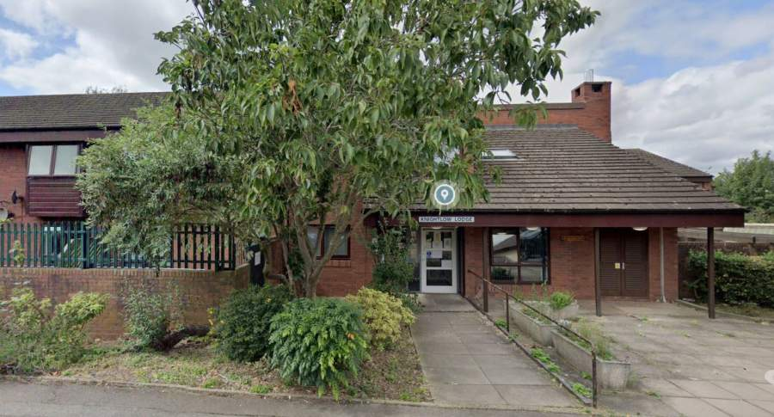 Knightlow Lodge

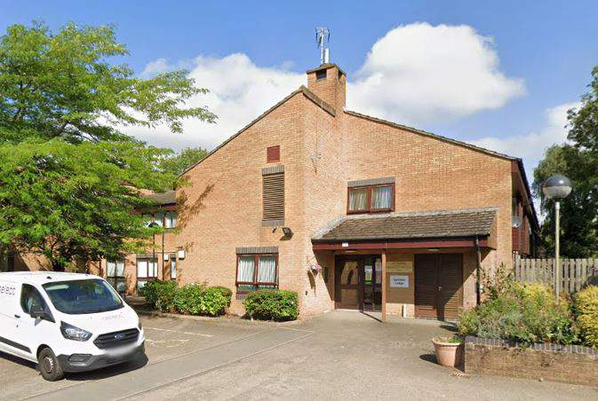 Quinton Lodge

Healthwatch Coventry
Citizens Advice Mid Mercia 114 Church St, Church Gresley, Swadlincote, Derbyshire, DE11 9NR
www.healthwatchcoventry.co.uk
Telephone: 0300 012 0315

Healthwatch Coventry
The Wheelhouse
Coventry City Council House
Earl Street
Coventry, CV1 5RR
www.healthwatchcoventry.co.uk
Telephone: 0300 012 0315
Email: yoursay@healthwatchcoventry.co.uk

Hosted by:
Citizens Advice Mid Mercia 114 Church St, Church Gresley, Swadlincote, Derbyshire, DE11 9NR



We briefed our Authorised Representatives about the project.

