
Housing with Care
A summary report on our findings
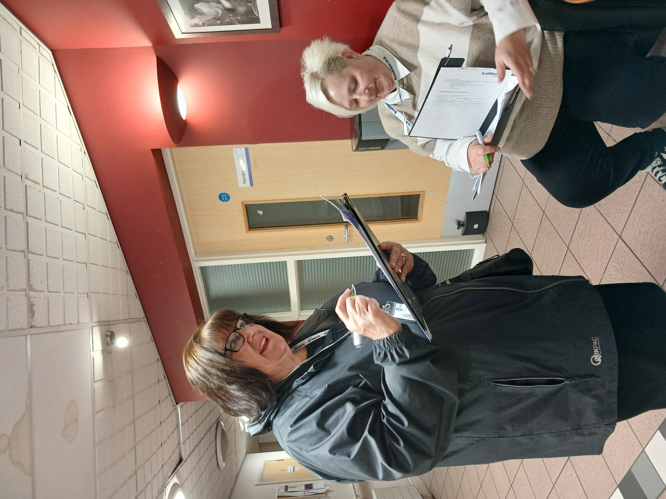
Alexandra House


Contents
Introduction 2
Methodology (how we did this research) 3
What residents told us 4
What staff told us 6
What we observed 7
Conclusion 8
Recommendations 9
Our thanks 13

Disclaimer:
This report is based solely on the views, experiences and feedback shared directly by people during our Enter & View Visit. Healthwatch Coventry acts as an independent voice for service users, reporting their words and perspectives verbatim without alteration, interpretation or addition of our own opinions. Our role is to amplify people’s voices to support service improvements, and the findings reflect only what was contributed on the day of the visit, not a comprehensive assessment of all experiences.
Acknowledgement
Terminology within this report reflects, what people say and how people describe their experience, both the language used by individuals and the correct service model.
People living in these schemes hold tenancy agreements and are therefore tenants. The term ‘resident’ is used to reflect everyday language people used, how people refer to themselves as and does not imply a residential care setting.
References to catering and activities also reflect language used during visits. Catering provisions available, although terminology (e.g. ‘restaurant’ or ‘café’) may vary. The provision of activities may also be from perspective of people, as these are not always commissioned, though some schemes provide them as an additional feature.
Our approach ensures the report reflects people’s voices while remaining factually accurate.

Introduction
Our role as Healthwatch Coventry is to hear the voices of those people who are using health and social care services, so that we can share their voices with services to help them to understand the issues and improve.
Our Housing with Care project developed the work that we had started in Autumn 2024 to look deeper into how people were experiencing their health and care services living in Housing with Care schemes.

We wanted to explore the services on offer to help schemes to understand the issues and improve.

The report looks at the environment, building, activities, communication, personalisation of services and care. Food and wellbeing of the people living in the schemes. We look at recommendations and highlighted areas for best practice. This report focuses on Alexandra House the building is managed by Anchor Housing, and the care is provided by Making Space who provide an onsite care service this a snapshot of what people felt and thought, as well as what we observed at the time.

At Alexandra House we spoke with 6 people about how they experienced the scheme, what care they received, and what they thought of that care, how they organised their food, what activities if any they participated in, and whether they found the building met their needs. From their replies we used themes to understand their experiences were and make recommendations for change.



“It’s very good. New staff haven't as much experience and don't understand needs as much”

Methodology
We created a survey for residents, staff, and family members to ask them about their experiences of their housing with care scheme
We visited each housing with care scheme and spoke to them about our visit and set a date to attend

We made observations at each scheme. Looking at the environment and interactions with members of staff and resident

We briefed our Authorised Representatives about the project

We raised awareness of our project through social media.
We have written a report outlining our findings and recommendations to go to housing with care schemes, Adult Social Care and Care Quality Commission for response.

When the responses are given, we will publish our report

At Alexandra House we spoke to 6 people about their experiences in this Housing with Care scheme.
We looked at:
- How personalised their experience was.
- How good the care and support and does it meet their needs
- What activities are available and what do they participate in, and what are their thoughts
- We asked whether residents received enough communication
- What the food was like in the café and did it meet their needs
- Whether the building and environment was livable and suitable

What residents told us

What we learned and what residents told us about their experiences in Housing with Care at Alexandra House.

What we learned Residents comments
Personalisation  4 out of 6 people that we spoke to said they rated their care 10/10  11 people out of the 40 people in the scheme receive care  We spoke to 6 people  Support  People had challenges getting access to other services and help when their care needs change   |  | ‘’I get everything I need. They are brilliant they are lovely staff they are they are local”.

“It took 18 months to get a social worker to get equipment otherwise have to pay for equipment for care mark have an Annual Review want to go inhouse for additional support.”

“Get on really well with staff. issue about night staff day staff more in line with running of service not regular night staff. I have no problem with day staff expect respect and dignity”

“They have a singer he is lovely he is very entertaining and he gets involved with all of us it’s a lovely evening”.

“Go down for social activities – birthdays nice to be part of the community”

“They are so approachable everyone works closely together - put notices at right height for wheelchairs”



“I went into hospital, when I came back here I had to have hospital carers and I didn’t like them. My relative and the manager got me carers at Alexandra House instead who are much better”

Resident’s comments What we learned

Communication

We asked if residents received enough information
5 out of 6 said yes
People feel listened to

Food and nutrition
There are not enough people interested in the café to make it viable.
It seems a shame as all the equipment is still there.

Building and Environment

We asked how do you feel about the building?
5 out of 6 people
think the building is good

The residents main concern is the lift.
Residents appear confident in the building and the environment

One person made a complaint which we passed on to our information signposting
“They have systems in place (for communication)
It really works we know everything”

“XX has done an awful lot for me, I went into hospital I had to have hospital carers and I didn’t like them. My relative and manager got me carers at Alexandra House instead”.

“Good but it only has one lift if the lift goes down we are totally stuck it happened one day”

“All right everything that happens in the building is repaired straight away got new facilities got a garden greenhouse”

“It’s clean bright and warm I have everything I need.”

“One resident wanted to make a complaint, so they were referred to the information helpline for more advice about their options”

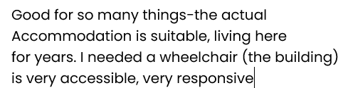


What staff told us
It’s satisfying and nice knowing that you have made some difference to someone
I like supporting the team and giving staff training and advice

Positive
Get good comments from residents making their day
It’s a very rewarding job lovely resident’s
I feel very well supported. I go to my manager if there are any problems
I receive training all the time I have had stoma and epilepsy training and can put forward for training in areas such as diabetes.

What could be improved
I think one thing we could improve about this scheme is activities
If a resident falls, we are not allowed to pick them up, we must call 999
Would like a full-time activities coordinator but we have a variety of age ranges older residents have families.

There are not enough work/hours here as many residents are non-care elsewhere - Poppy Court/Bevan Court.
I don’t like travelling between schemes
If there were more training, we would do it

What we observed
There was no canteen, although there were still equipment/ fridges/ work tops in the kitchen area |  | Residents told us they do use the lounge for family parties and get togethers
The lounge is not used, and it was empty when we were there but people said it was a nice space if they wanted to get out of their rooms to read a book |  | Support worker entered resident's apartment to clean told the resident they were coming in to clean resident asked her to start in bathroom & bedroom which she did
The lounge was a lovely spacious area with lots of room and light |  | Outside- Good signage disabled parking not clear
The building felt very clean there were no smells |  | Intercom system CCTV entrance- Clean warm welcoming nice décor handrails different colour
Observed staff talking to resident |  | Corridors calm uncluttered
Manager in office talking in depth to one resident while on the phone |  | Felt well organised and busy with residents going out and about  Those who are less able seem happy with their care
One of our Authorised Representatives was unable to enter a resident’s apartment because it was too smoky, so they stood at the door looking in

Conclusion
Housing with Care schemes are valuable in terms of the support they provide to people who can no longer live independently at home due to their mental and physical needs and do a great job in sometimes difficult circumstances – lack of staff, changing needs of residents and other things impact on the service.
Alexandra House had 11 people receiving care, we spoke to five people so most of the residents are living their lives independently. There is no café available, most residents had to either make meals in their rooms or have meals prepared by carers. Some resident’s relatives brought them food.
The residents told us how much they value, appreciate, and rate the care they receive and the support of their carers.
Two people mentioned the night staff as they did not always know who they were or what they were doing.
Residents were very fond of their carer’s and found the care they received during the day met their needs and they can live independent lives.
The activities seem to revolve around people’s parties and events held in the lounge, as there were not many activities being organized, due to staff restrictions.
For some areas smoke from cigarettes was an issue as it could be smelt across the corridor
This provides a strong foundation to build on through continued partnership working

Please see below our recommendations that we are asking you to respond to, to say what you are doing or what you are planning to do (you may already be taking lots of actions to meet these recommendations. Please complete our recommendations using the table and return it to us – see the next steps.

Recommendations
What could help improve the service
Issue | Recommendation | Response
Some residents are not sure about who the night staff are and feel uncomfortable | Have a leaflet or explain who night staff are and what they are doing, find out why people find this difficult. | We believe that this  comment came from a  lady who receives outside  care. Our night staff have  all been here for 20 years  + we have 3-night staff  members, and everybody  knows who they are.
Due to lack of residents who receive care staff have to go elsewhere to make their hours up | Clear information given to anyone being employed knows they have to work multiple sites | This practice is a strategic operational necessity to ensure job security and service continuity. Alexandra House is registered under an Outreach Service. Our  service operates on  assessed hours which  naturally fluctuates.  During recruitment all  staff are explicitly briefed  that they may be  required to work at other  locations to fulfil their  contracted hours. This is  clearly documented on  their contracts. By  deploying staff across  the outreach framework  we prevent the need for  redundancies or zero  hour uncertainty during  periods where onsite care decrease.
Look at alternative to lift | Scope out chair lifts | If our lift breaks down our  lift engineers would attend within 4 hours to repair the lift. if they do  need to wait for parts  depending on the length  of time chair lifts can be  put in on a temporary  basis
Links to social workers and reviews for residents to get the equipment and support they need | How does this work – carers/manager can follow this up who is responsible for supporting people who need care to help with this? | We maintain a proactive and immediate referral process for all residents receiving care from the onsite care provider. If a resident needs to change our policy is to contact social services immediately for a review or equipment assessment. We have a proven track record of managing these transitions without delay or issue. However, the audit mentions care mark. There is only one resident with an outside agency responsibility for equipment and social work liaison for external packages lie solely with that specific outside agency so this concern should of been directed to that care provider as the onsite provider does not have the jurisdiction to intervene in external care contracts. As the housing provider manager, I can only assist in resolving barriers if I am made aware of them. To date no such issues was reported.
Very few activities on site | Link up with other Housing with Care schemes who provide regular activities | The level of activity is a direct reflection of our resident's independence and personal choice rather than lack of provision. 95% of our residents are fully independent and frequently choose to access the community and external amenities rather than stay on site for organised events. We have consistently attempted to involve able bodied residents in co-producing activities, but uptake remains low. Our notice boards are regularly updated with options, yet residents feedback remains consistent. We have held formal meetings to establish what residents want. The consensus is a preference for low pressure social events e.g coffee mornings, breakfast mornings and cream tea afternoon which have been provided by the housing manager. The care team remains flexible and actively support birthdays, quizzes and bingo sessions. We believe in a person-centred approach forcing activities on a population that prefers independence would be counter intuitive to their wellbeing.

General Recommendations
Recommendation | Response | Date
Making sure car park areas are clean of rubbish plastic gloves), disabled bay marked clearly | Car park has been cleared we had an outside agency that was disposing of the waste in our car park this has now been dealt with, and the car park is cleared regularly by myself and  the housekeeper. Job will be raised to repaint the disabled parking spaces. | 12th February 2026
Ensure hot and cold taps are marked accordingly | I will need more information (**Healthwatch has responded clear stickers/signage would be sufficient) | 12th February 2026
Have an easy-to-follow leaflet (or other communication) for new residents explaining insurance, resident's meetings | Insurance is discussed at sign up for home contents and mobility scooters electric wheelchairs etc, and we have a moving and settling in checklist that we go through on  someone moving in residents meeting dates  are put into the newsletters and a sent round  individually to flats on a separate piece of paper so, they don’t get missed they are also displayed on the notice board 3 months at a time. On the day of the meeting a call  is put out across the scheme to remind residents the meeting with be starting shortly to give them time to get down. Care staff can  assist with resident who struggle to get down to the lounge. | 12th February 2026
Look at good quality and more diverse cultural dishes on the menu | Our kitchen has been decommissioned and  although some of the equipment is still there it’s been disconnected. Anchor provide meals on a ‘condition of tenancy’ basis and residents would have to agree to take up this service to ensure that it is viable. | N/A
Look at colourful posters and fliers in large print and that people in wheelchairs can access | I will be making a folder of all the notices and  keeping them in a folder that wheelchair users can access, and they will be in large print. | 1st March 2026
Look at resources and funding for activities | *No response* | N/A
Ask residents what they would like to see as activities – have a suggestion box | We have a suggestion box in our lounge, and it has been there for at least 5 years. We also ask this question at almost every customer meeting and if there is something that they would like to do we try to provide that for them. | On Going
Ensure that all staff know what activities are happening in the scheme and can talk about them to residents | Staff are fully aware of what activities are happening at Alexandra House as there are posters up for any up coming events this is also communicated to staff verbally | On Going

Impact:
Healthwatch Coventry will continue to work with partners to review progress and support improvements.
Accountability - recommendations section:
We expect responses to outline actions, timelines and how improvements will be monitored.

What Happens next,
This report and recommendations will have been sent to Housing with Care group managers for a response to our recommendations, these have been added to this report. We will then review the actions after three and six months to see if these actions have been followed.

If you would like more information or have questions about this report, please contact yoursay@healthwatchcoventry.co.uk

Our Thanks
To all the residents and staff at Alexandra House, Housing with Care units for allowing us to speak with them and for sharing with us a glimpse of their lives and experiences.
Thanks to the managers who helped and supported us to set dated and help us on the day.
A big thank you to the Healthwatch Coventry Authorised Representatives who are crucial to make the work happen.



Alexandra House


Healthwatch Coventry
The Wheelhouse
Coventry City Council House
Earl Street
Coventry, CV1 5RR
www.healthwatchcoventry.co.uk
Telephone: 0300 012 0315
Email: yoursay@healthwatchcoventry.co.uk

Hosted by:
Citizens Advice Mid Mercia 114 Church St, Church Gresley, Swadlincote, Derbyshire, DE11 9NR

